Modeling:
1. Feature Engineering
Feature engineering is one of the most important stages of machine learning because the quality of features directly affects the performance of predictive models. It involves selecting relevant variables, transforming the data into a suitable format, and preparing the dataset for model training.
In this project, the objective is to predict the life expectancy of the year 2100 using historical life expectancy values from previous years. Therefore, the country code (geo) and country name (name) are removed since they do not directly contribute to numerical prediction. All historical yearly life expectancy values are used as input features, while the life expectancy value for the year 2100 is selected as the target variable.
Feature scaling is applied using StandardScaler to normalize the numerical features. Standardization improves the performance of distance-based machine learning algorithms such as K-Nearest Neighbors (KNN) and Support Vector Regression (SVR) by ensuring that all features have similar scales.
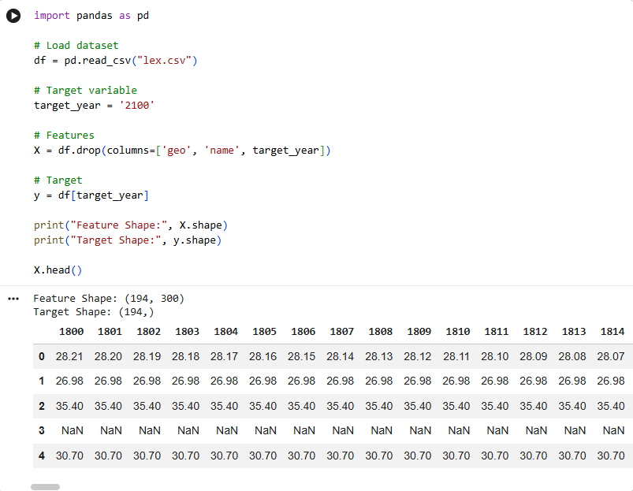
  - Feature Scaling
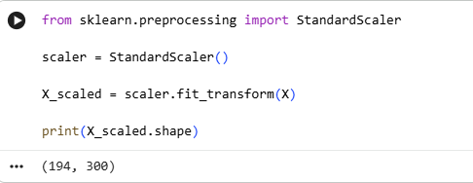
  - Train-Test Split
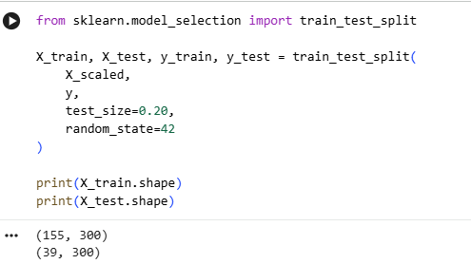
1.3 Five Fold Cross Validation
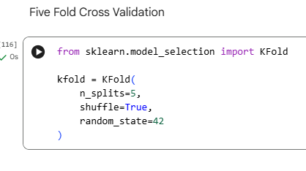
2. Modeling
Several regression algorithms are trained and evaluated to determine which model provides the most accurate life expectancy prediction. Each model is trained using the same training dataset and evaluated on the testing dataset. Five-Fold Cross Validation is also used to obtain a more reliable estimate of model performance.
The following regression algorithms are implemented:
- Linear Regression
- Decision Tree Regressor
- K-Nearest Neighbors Regressor
- Support Vector Regressor
- Random Forest Regressor
Each model predicts the life expectancy for the target year using historical life expectancy records.

2.1 Linear Regression

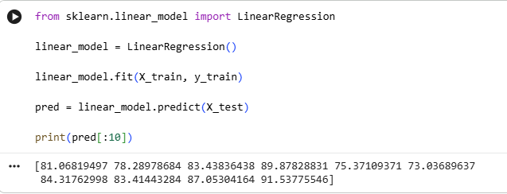

2.2 Decision Tree Regressor
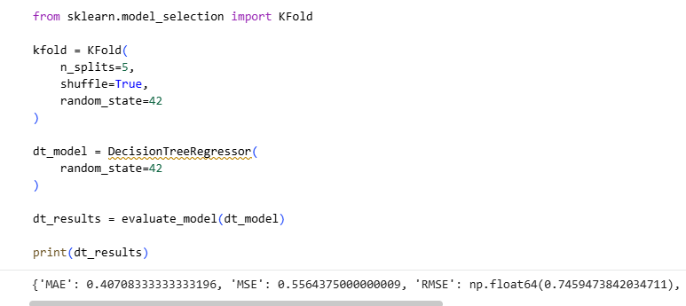
2.3 KNN Regressor
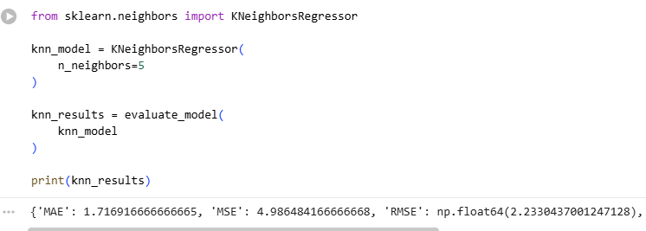
2.4 Support Vector Regressor
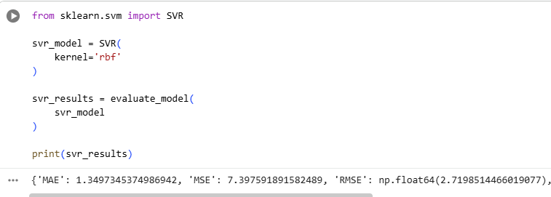
2.5 Random Forest Regressor
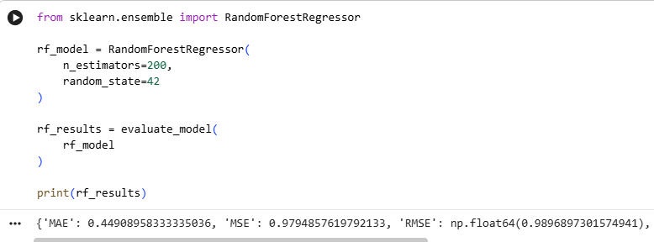

3. Description of algorithms used
3.1 Linear Regression
Linear Regression is a supervised machine learning algorithm used to predict continuous numerical values by establishing a linear relationship between the input variables and the target variable. It assumes that the dependent variable changes linearly with respect to the independent variables. Due to its simplicity and interpretability, Linear Regression is commonly used as a baseline model in regression problems.
3.2 Decision Tree Regressor
Decision Tree Regressor predicts numerical values by recursively splitting the dataset into smaller subsets based on feature values. The algorithm creates a tree-like structure where each internal node represents a decision rule and each leaf node represents the predicted output. Decision Trees can capture nonlinear relationships but may overfit if not properly controlled.
3.3 K-Nearest Neighbors (KNN) Regressor
KNN Regressor predicts the output of a data point by averaging the values of its nearest neighboring observations. The algorithm calculates the distance between the new observation and all training samples, selects the nearest K neighbors, and computes their average. KNN performs well when similar observations are located close together in the feature space.
3.4 Support Vector Regressor (SVR)
Support Vector Regression extends the Support Vector Machine algorithm for regression tasks. Instead of separating classes, SVR attempts to fit the best regression line within a specified error margin. It is capable of modeling both linear and nonlinear relationships through the use of kernel functions and generally performs well on complex datasets.
3.5 Random Forest Regressor
Random Forest Regressor is an ensemble learning algorithm that combines the predictions of multiple Decision Trees to produce a more accurate and robust prediction. Each tree is trained using a random subset of samples and features, reducing overfitting while improving generalization. Random Forest is widely used because of its high predictive performance and ability to estimate feature importance.

4. Results with appropriate metrics
4.1 Comparison of Mean R² Score

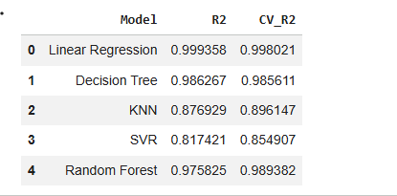
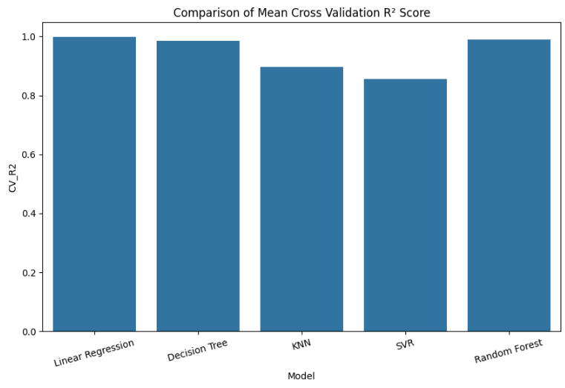
4.2 Mean Absolute Error (MAE)
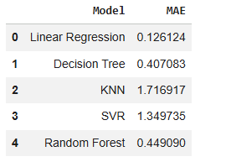
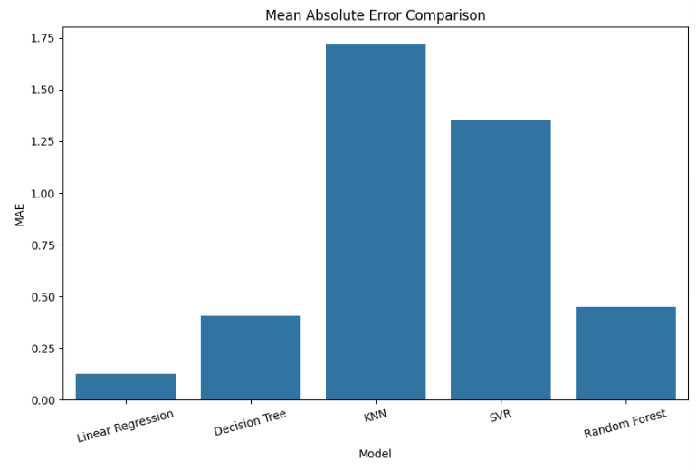
4.3 RMSE Comparison
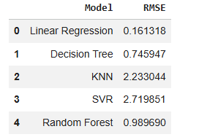
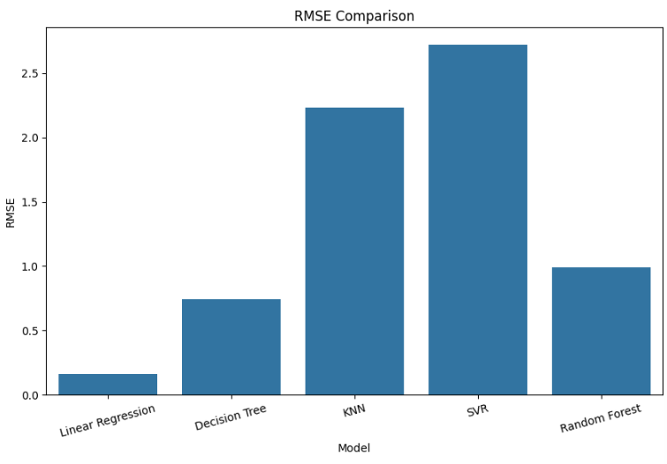
4.4 MSE Comparison
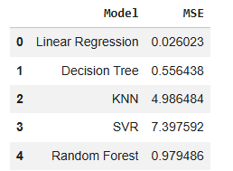
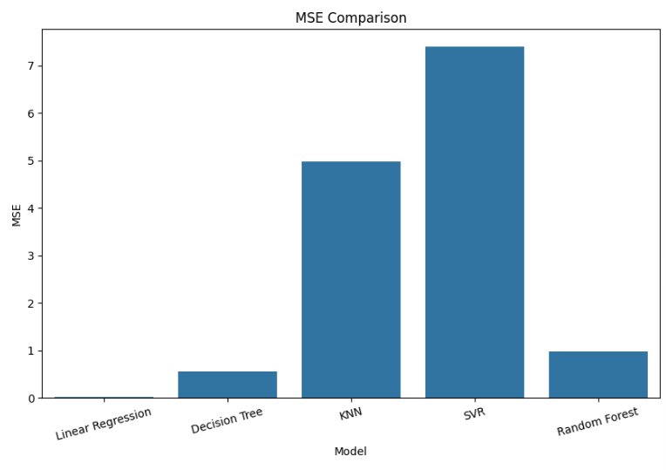
4.5 Best Model Selection
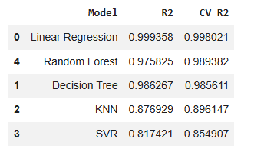

5. Discussion and conclusion
Discussion
The performance of all regression models was evaluated using Mean Absolute Error (MAE), Mean Squared Error (MSE), Root Mean Squared Error (RMSE), R² Score, and Five-Fold Cross Validation R². Lower values of MAE, MSE, and RMSE indicate smaller prediction errors, whereas a higher R² score indicates that the model explains a greater proportion of the variance in life expectancy. The comparison of these metrics helps identify the most suitable model for predicting life expectancy.

Conclusion
This project demonstrated the application of several machine learning regression algorithms for predicting global life expectancy. Historical life expectancy records were successfully used as input features after appropriate preprocessing and feature scaling. Multiple regression models were trained and evaluated using standard performance metrics and Five-Fold Cross Validation. The model with the highest Cross Validation R² score and the lowest prediction error can be selected as the best-performing model for this dataset. Overall, the project highlights the effectiveness of regression techniques in analyzing long-term life expectancy trends and provides a strong foundation for future predictive studies.

Exercises
Lab 1 — Loading and Inspecting Data
Exercise 1. How many rows and columns does tips have? Which columns are numeric and which are categorical? Are any values missing?

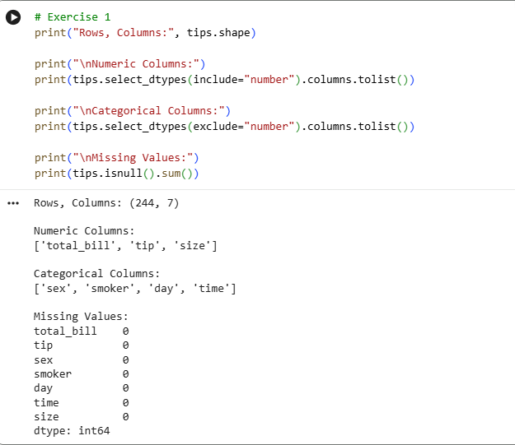

Exercise 2. Show summary statistics for the numeric columns. What is the largest total bill?
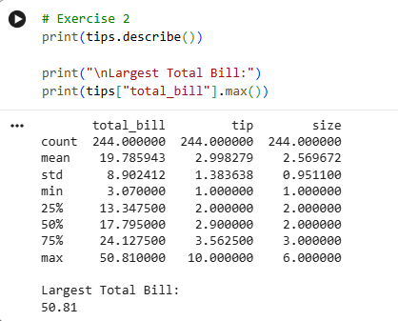
Exercise 3. How many smokers vs. non-smokers are in the data? (Hint: value_counts.)
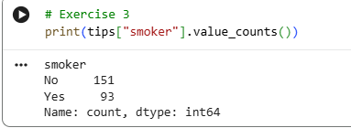
Exercise 4. Select all rows where the bill is above 40 dollars and the party size is at least 4. How many are there?
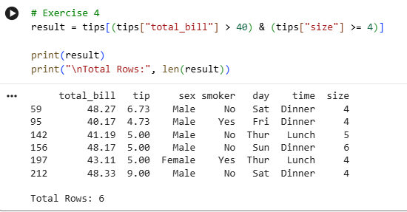
Exercise 5. Using groupby, compute the average tip for each day of the week. Which day tips best?
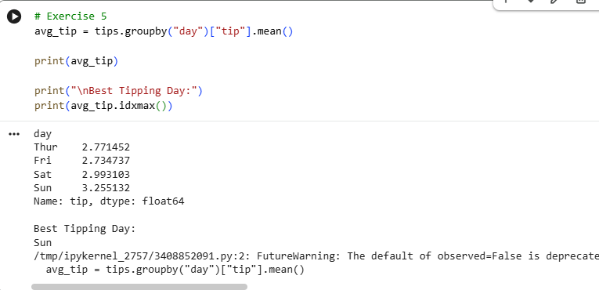

Lab 2 — Data Cleaning and Preprocessing

Exercise 1. Standardize the column names: strip spaces, lowercase, and replace ($) so the names are valid identifiers like salary.
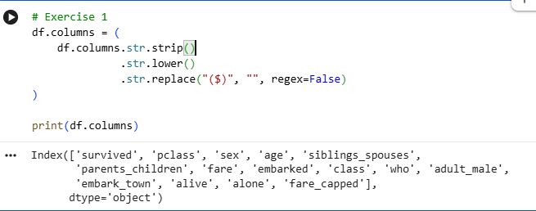
Exercise 2. Age is stored as text and contains an impossible value. Convert it to numeric and deal with the 199. Justify your choice.
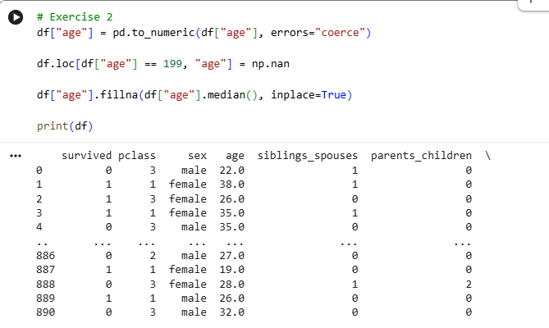
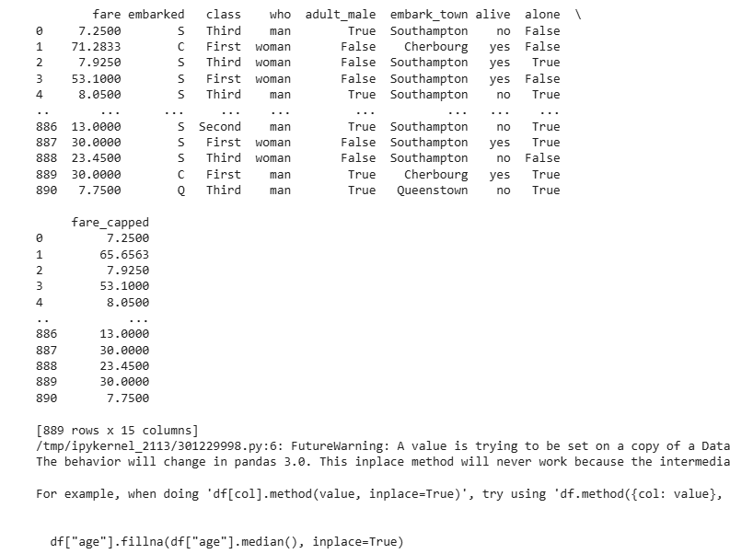
Exercise 3. Clean the Name and City text (strip, consistent case), then find and remove the truly duplicated row.
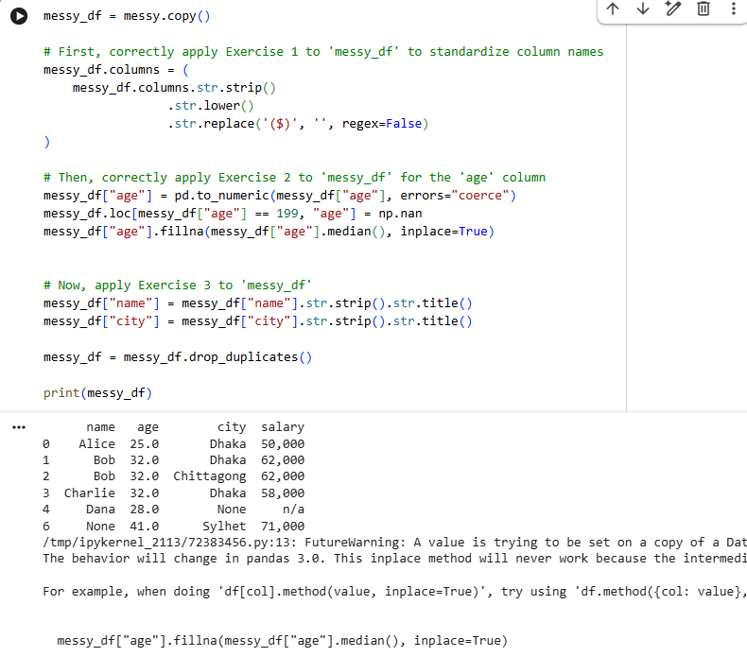

Exercise 4. Convert Salary($) to numeric (careful: commas and "n/a"), then fill the missing salary with a value you think is reasonable — and write one sentence defending the choice.
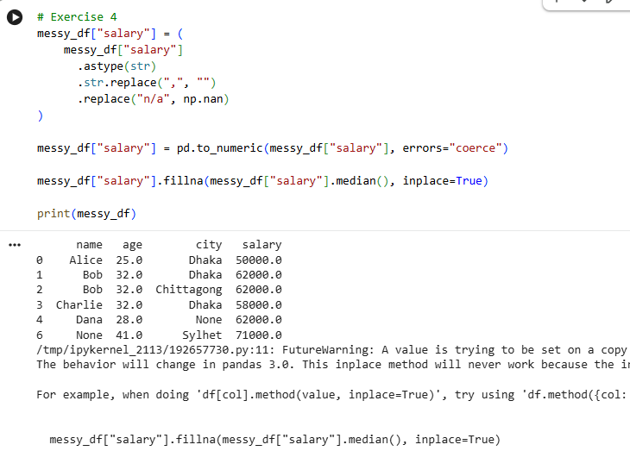
Exercise 5. Save your cleaned DataFrame to messy_clean.csv and reload it to verify.
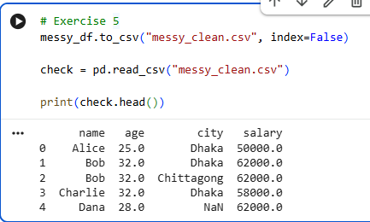

Lab 3 — Feature Engineering
Exercise 1. Create total_cost = fare + tip + tolls, then use pd.qcut to bin it into "cheap", "normal", "expensive" (3 equal-sized groups). How many rides fall in each?
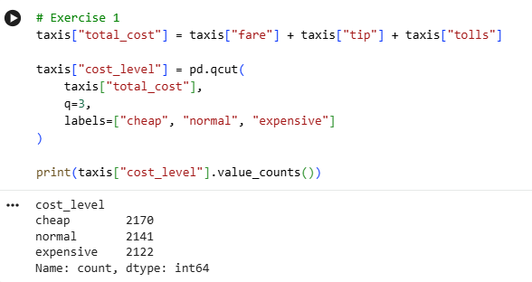
Exercise 2. Create speed_mph = distance / (duration_min / 60). Check it with .describe() — do you find suspicious values? Where do they come from?
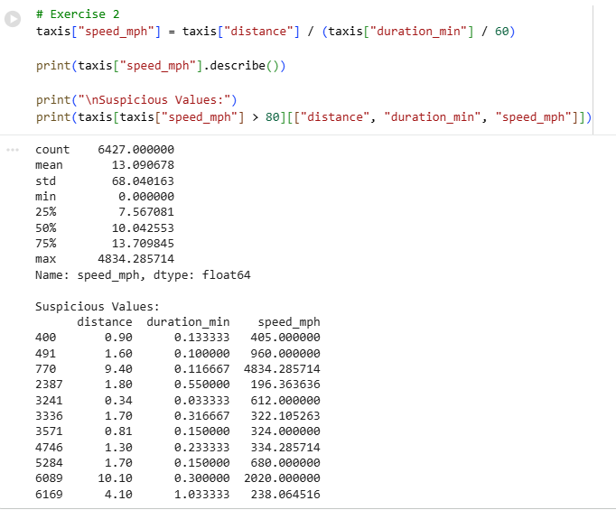
Exercise 3. Using map, create a payment_short column where "credit card" → "card" and "cash" stays "cash".
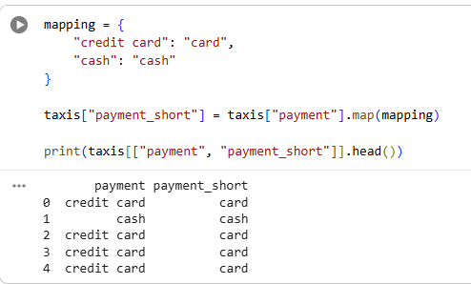
Exercise 4. Using groupby().transform(), add the average tip per pickup_day, then find which day has the most generous average tip.
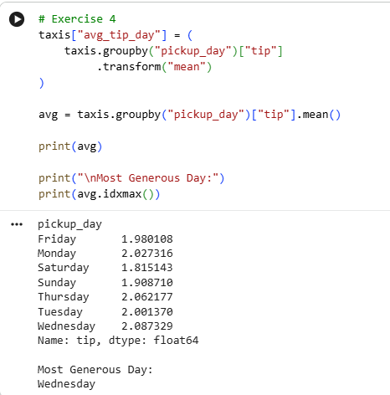
Exercise 5. Validate one of your new features with a quick plot (e.g. a bar chart of average speed per pickup hour). Write one sentence about what it shows.
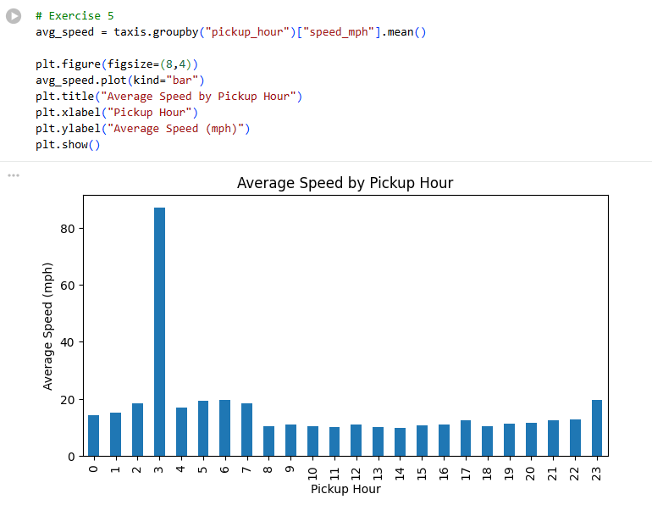

Lab 4 — Data Visualization with Matplotlib and Seaborn

Exercise 1. A histogram of bill_length_mm with a sensible number of bins. Is the distribution skewed? Could there be more than one bump — and why might that be?

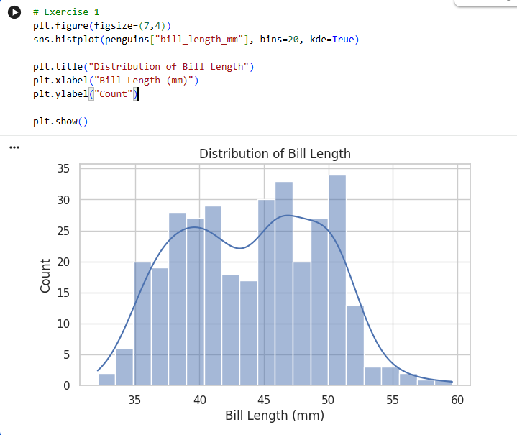

Exercise 2. A scatter plot of bill_length_mm vs bill_depth_mm, colored by species. Do clusters appear?

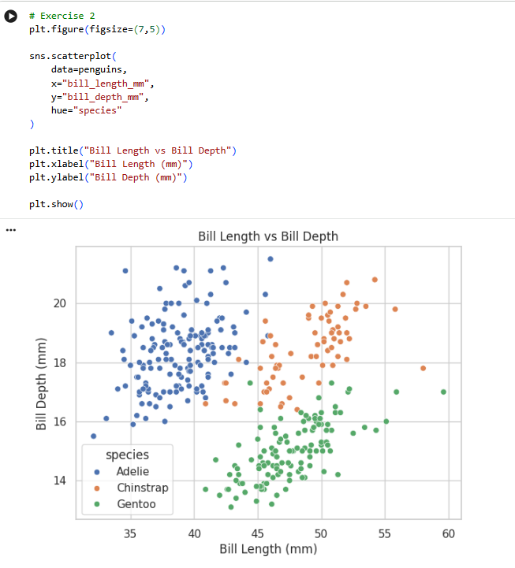

Exercise 3. Grouped boxplots of flipper_length_mm per island. Which island hosts the biggest penguins? (Bonus: which species lives there? Check with value_counts.)
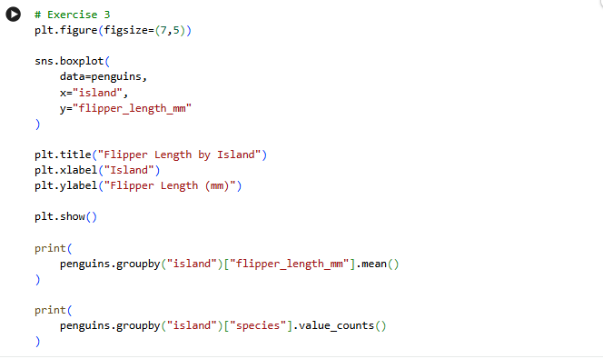
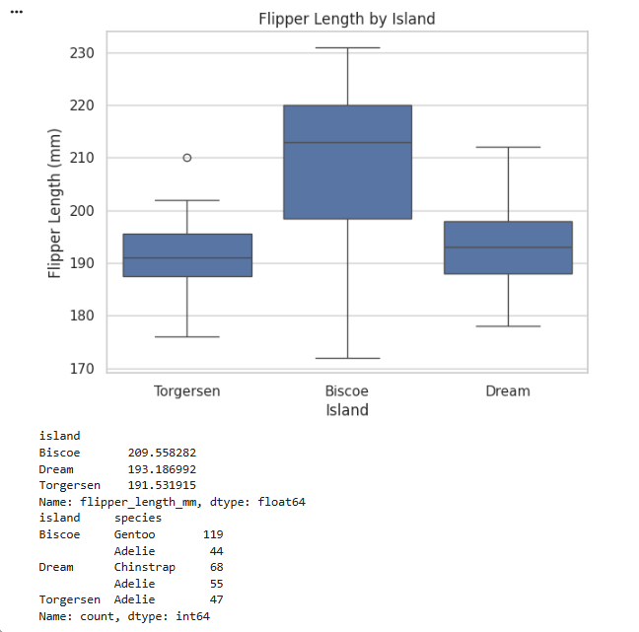
Exercise 4. A figure with two subplots side by side: left, a countplot of species; right, a barplot of mean body_mass_g per species. Use plt.subplots(1, 2, ...).

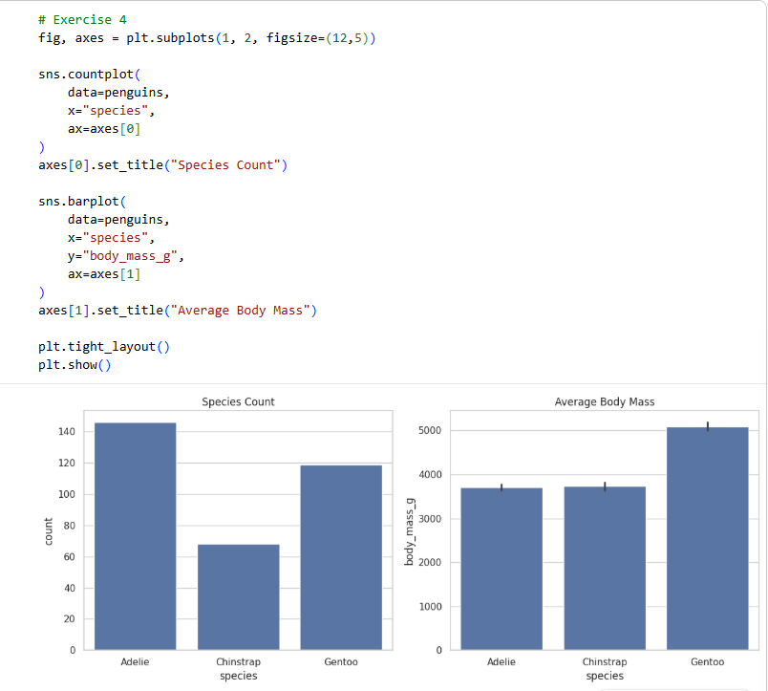

Exercise 5. Save your favorite of the four as a PNG at dpi=150 and download it from the Colab file panel.
